AIML SESSION 05 ASSIGNMENT SUBMISSION

Name of student: Vaibhav Vijay Kate
Domain/subject name: AIML (Artificial Intelligence & Machine Learning)
College and Branch name: Government Polytechnic College Washim (IF)
Q1. (String Indexing)
Write a program that takes a string input from the user.
Print:
- The first character
- Code:The last character (using negative index)
- The 3rd character from the start
- The 2nd character from the end
Add comments explaining positive and negative indexing.
Program Code:
#Take a string input from the user
name=input("Enter a string: ")

#The first character of the string can be accessed using index 0 (positive indexing)
print("The first character is:", name[0])

#The last character of the string can be accessed using index -1 (negative indexing)
print("The last character is:", name[-1])

#The 3rd character from the start can be accessed using index 2 (positive indexing)
print("The 3rd character from the start is:", name[2])

#The 2nd character from the end can be accessed using index -2 (negative indexing)
print("The 2nd character from the end is:", name[-2])

Output Screenshot:
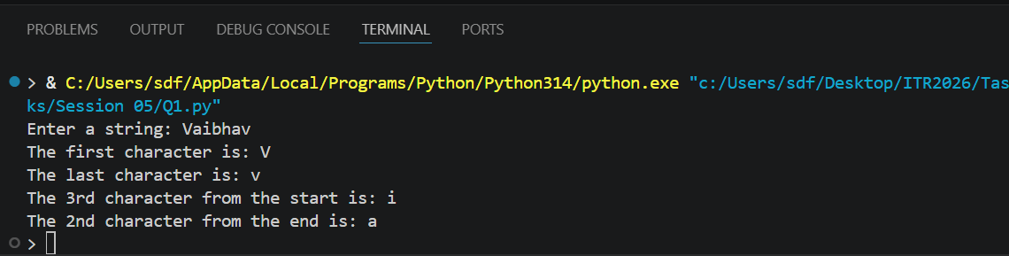

Q2. (String Slicing)
Take a string input from the user.
Using slicing, print:
a) The first 5 characters
b) The last 4 characters
c) The string in reverse order
d) Every 2nd character of the string
Include comments explaining the slicing syntax [start:end:step].
Program Code:
# Take a string input from the user
name = input("Enter a String:")

# a) The first 5 characters can be accessed using slicing with start index 0 and end index 5 (exclusive)
print("The first 5 characters are:", name[0:5])

# b) The last 4 characters can be accessed using slicing with start index -4 and end index as the length of the string (exclusive)
print("last 4 characters are:", name[-4:])

# c) The string in reverse order can be accessed using slicing with start index as the length of the string, end index as -1 (exclusive), and step as -1 (to reverse the string)
print("The string in reverse order is:", name[::-1])

# d) Every 2nd character of the string can be accessed using slicing with start index 0, end index as the length of the string (exclusive), and step as 2 (to skip every 2nd character)
print("Every 2nd character of the string is:", name[0::2])

Output Screenshot :
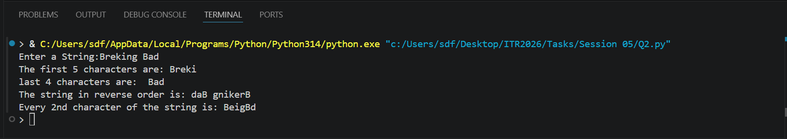

Q3. (String Membership)
Write a program that:
- Takes a main string and a substring as input from the user.
- Checks whether the substring is present in the main string using in and not in.
- Prints appropriate messages (e.g., "Substring found!" or "Substring not found!").
- Note that it is case-sensitive.
Program Code:
# Take a main string input from the user
main_string = input("Enter the main string: ")

# Take a substring input from the user
substring = input("Enter the substring: ")

# Check if the substring is present in the main string
if substring in main_string:
print("Substring found!")
else:
print("Substring not found!")

Output Screenshot :
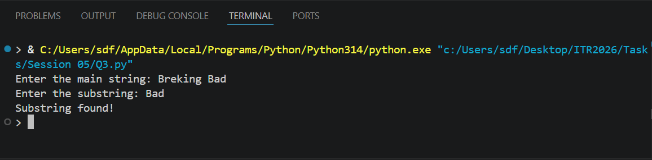
Q4. (len() Function)
Write a program that:
- Takes a string as input.
- Prints the length of the string using len().
- Prints the last character using len() (without using negative index).
- Prints the middle character if the length is odd.
Add comments on common mistakes with len().
Program Code:
# Take a string input from the user
input_string = input("Enter a string: ")

# Print the length of the string using len()

print("The length of the string is:", len(input_string))

# Print the last character using len() (without using negative index)
print("The last character is:", input_string[len(input_string) - 1])

# Print the middle character if the length is odd
if len(input_string) % 2 == 1:
middle_index = len(input_string) // 2
print("The middle character is:", input_string[middle_index])
else:
print("The string has an even length, so there is no single middle character.")

OUTPUT Screenshot:
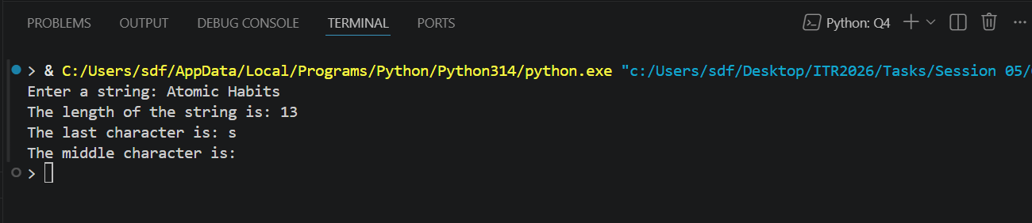
Q5. (range() - Basic Forms)
Write a program using for loop and range() to:
a) Print numbers from 0 to 10.
b) Print numbers from 5 to 15.
c) Print odd numbers from 1 to 21.
Explain the three forms of range() in comments.
Program Code:
# a) To print numbers from 0 to 10, we can use range() with a single argument which specifies the end of the range (exclusive). The start is by default 0 and the step is by default 1.
print("Numbers from 0 to 10:")
for i in range(11): # This will generate numbers from 0 to 10 (11 is exclusive)
print(i)

# b) To print numbers from 5 to 15, we can use range() with two arguments: the start and the end. The start is inclusive and the end is exclusive.
print("Numbers from 5 to 15:")
for i in range(5, 16): # This will generate numbers from 5 to 15 (16 is exclusive)
print(i)

# c) To print odd numbers from 1 to 21, we can use range() with three arguments: the start, the end, and the step. The step is set to 2 to get only odd numbers.
print("Odd numbers from 1 to 21:")
for i in range(1, 22, 2): # This will generate odd numbers from 1 to 21 (22 is exclusive)
print(i)

OUTPUT Screenshot:
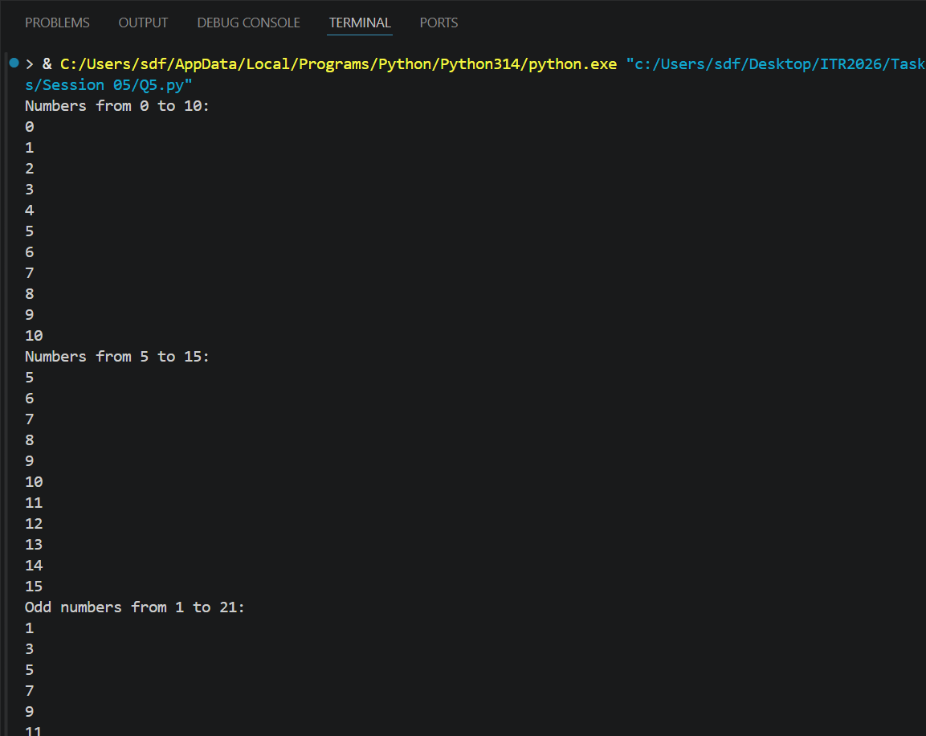
Q6. (range() with Negative Step)
Use range() to print:
- Numbers from 20 down to 10 (decreasing).
- Numbers from 15 down to 1 in steps of 2.
Print each sequence on a new line with proper messages.
Program Code:
# a) To print numbers from 20 down to 10, we can use range() with three arguments: the start, the end, and the step. The start is 20, the end is 9 (since it's exclusive), and the step is -1 to decrease the numbers.
print("Numbers from 20 down to 10:")
for i in range(20, 9, -1):
print(i)

# b) To print numbers from 15 down to 1 in steps of 2, we can use range() with three arguments: the start, the end, and the step. The start is 15, the end is 0 (since it's exclusive), and the step is -2 to decrease the numbers.
print("Numbers from 15 down to 1 in steps of 2:")
for i in range(15, 0, -2):
print(i)

OUTPUT Screenshot:
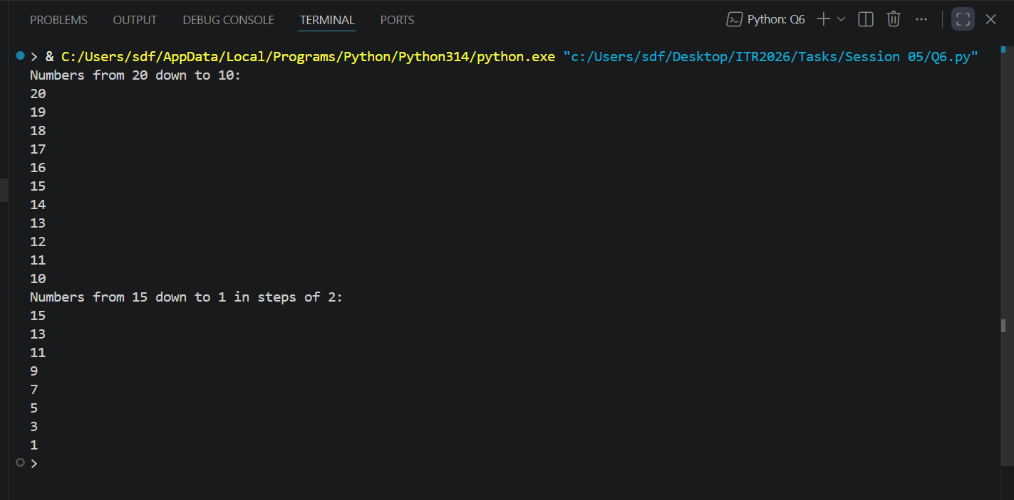

Q7. (Combined: Strings + range())
Write a program that takes a string from the user.
Using a for loop and range() with len(), print:
- Each character of the string one by one (with its index).
- The string in reverse order using negative step in range().
Program Code:
# Take a string input from the user
user_string = input("Enter a string: ")

# Print each character with its index
print("Characters with indices:")
for i in range(len(user_string)):
print(f"Index {i}: {user_string[i]}")

# Print the string in reverse order
print("String in reverse order:")
for i in range(len(user_string) - 1, -1, -1):
print(user_string[i], end="")
print() # Print a newline at the end

OUTPUT Screenshot:
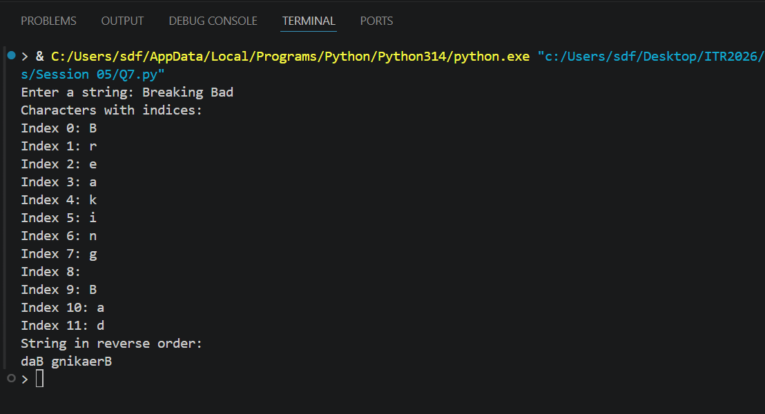
Q8. (Membership with range())
Write a program that:
- Takes a number as input from the user.
- Checks if the number is present in range(1, 51) and in range(10, 100, 5).
- Prints clear messages for each check.
Program Code:
# Take a number as input from the user
number = int(input("Enter a number: "))

# Check if the number is in range(1, 51)
if number in range(1, 51):
print(f"{number} is in the range(1, 51).")
else:
print(f"{number} is not in the range(1, 51).")

# Check if the number is in range(10, 100, 5)
if number in range(10, 100, 5):
print(f"{number} is in the range(10, 100, 5).")
else:
print(f"{number} is not in the range(10, 100, 5).")

OUTPUT Screenshot:
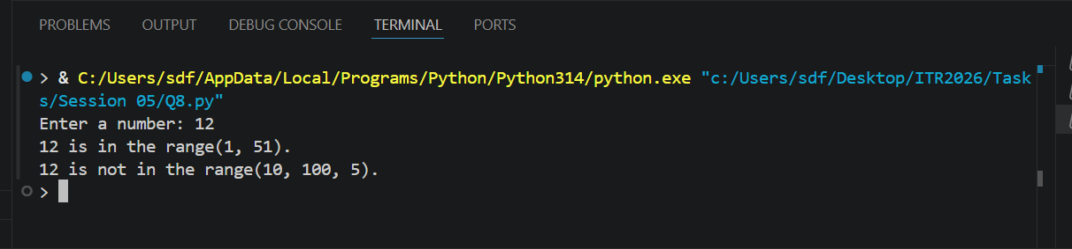
Q9. (Slicing + range())
Write a program that prints the following using range() and string slicing concepts
where applicable:
- First 10 even numbers (2 to 20).
- Numbers from 1 to 30 in steps of 3.
- A string "PythonProgramming" sliced to show "Python", "Programming", and the reverse.
Program Code:
# a) To print the first 10 even numbers from 2 to 20, we can use range() with a step of 2 starting from 2.
print("First 10 even numbers from 2 to 20:")
for i in range(2, 21, 2):
print(i)

# b) To print numbers from 1 to 30 in steps of 3, we can use range() with a step of 3 starting from 1.
print("Numbers from 1 to 30 in steps of 3:")
for i in range(1, 31, 3):
print(i)

# c) To slice the string "PythonProgramming", we can use string indexing.
user_string = "PythonProgramming"
print(f"Original string: {user_string}")
print(f"First 6 characters: {user_string[0:6]}")
print(f"Last 11 characters: {user_string[6:17]}")
print(f"Reversed string: {user_string[::-1]}")

OUTPUT Screenshot:
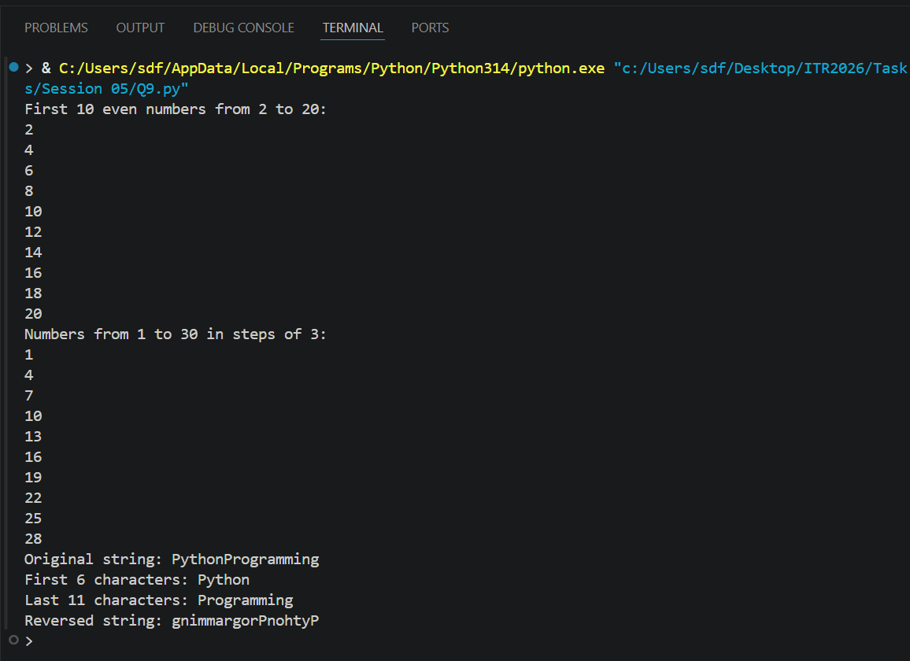

Q10. (Mini Project - Combined)
Create a String Analyzer program:
- Take a string input from the user
- Using functions or directly:
1. Print length of the string.
2. Print first half and second half using slicing.
3. Check if the word "python" (case insensitive — you may convert) is
present.
4. Use range() to print all characters with their positive and negative indices.
5. Print the string in reverse.
Add proper comments and use meaningful variable names.
Program Code:
# Take a string input from the user
input_string = input("Enter a string: ")

# 1. Print length of the string
string_length = len(input_string)
print("Length of the string:", string_length)

# 2. Print first half and second half using slicing
half_index = string_length // 2
first_half = input_string[:half_index]
second_half = input_string[half_index:]
print("First half of the string:", first_half)
print("Second half of the string:", second_half)

# 3. Check if the word "python" (case insensitive) is present
if "python" in input_string.lower():
print("The word 'python' is present in the string.")
else:
print("The word 'python' is not present in the string.")

# 4. Use range() to print all characters with their positive and negative indices
print("Characters with positive and negative indices:")
for i in range(string_length):
print(f"Index {i}: {input_string[i]} (Negative Index: {i - string_length})")

# 5. Print the string in reverse
reversed_string = input_string[::-1]
print("String in reverse:", reversed_string)

OUTPUT Screenshot:
